**Project Design Phase-II**

**Data Flow Diagram & User Stories**

|  |  |
| --- | --- |
| Date | 22 October 2022 |
| Team ID | PNT2022TMID23716 |
| Project Name | Smart fashion recommender application |
| Maximum Marks | 4 Marks |

**Data Flow Diagrams:**

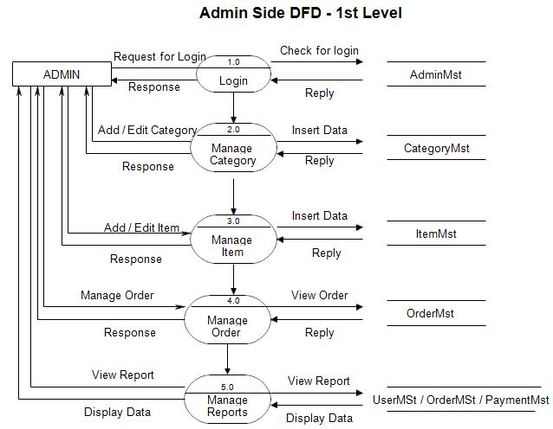

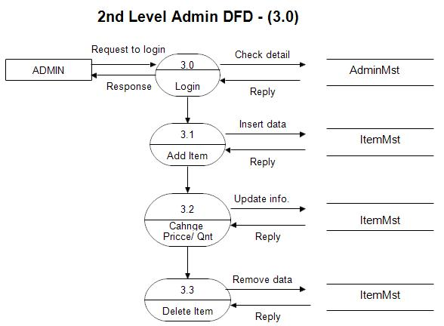

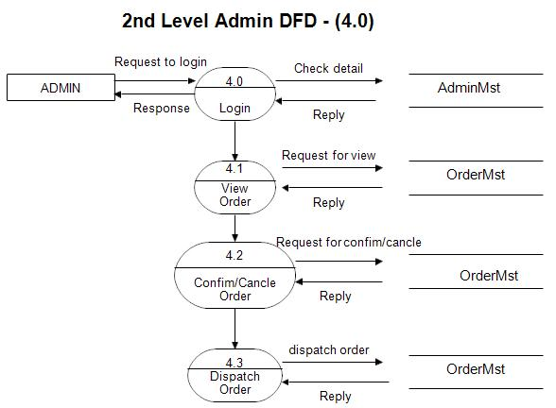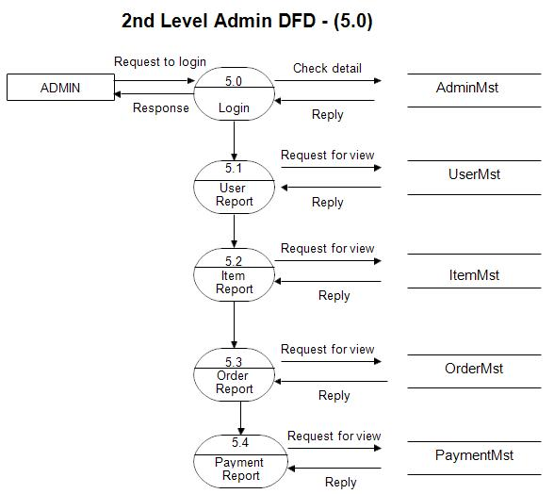

## **User side Data flow Diagram**

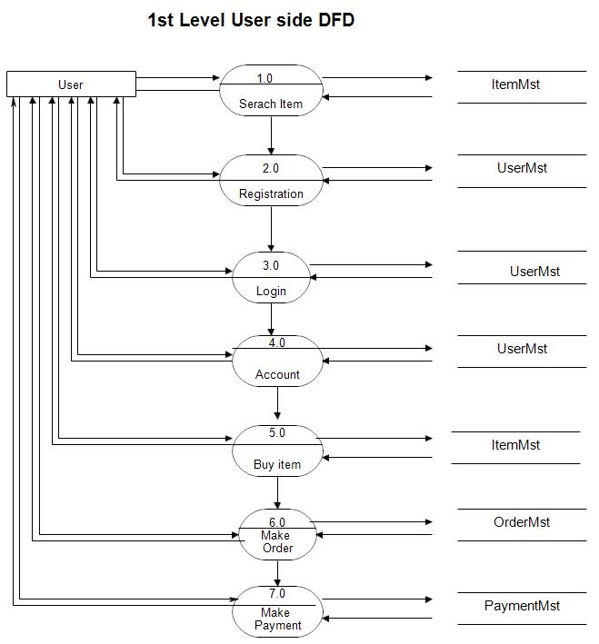

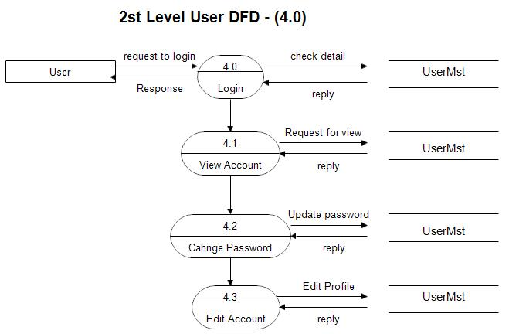

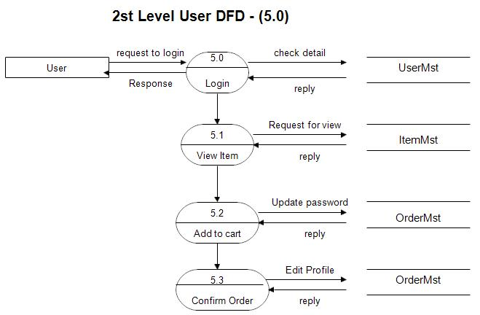

|  |  |  |  |  |  |  |
| --- | --- | --- | --- | --- | --- | --- |
| **User Type** | **Functional**  **Requirement**  **(Epic)** | **User Story Number** | **User Story / Task** | **Acceptance criteria** | **Priority** | **Release** |
| Customer  (Mobile user) | Registration | USN-1 | As a user, I can login by entering my email, password, and confirming my password. | I can access my account / dashboard | High | Sprint-1 |
|  |  | USN-2 | As a user, I will receive confirmation email once I have registered for the particular menu | I can receive confirmation email & click confirm | High | Sprint-1 |
|  |  | USN-3 | As a user, I can view the menus through Facebook and other social media platforms | I can register & access the dashboard with Facebook  Login | Low | Sprint-2 |
|  |  | USN-4 | As a user, I can register for the application through Gmail |  | Medium | Sprint-1 |
|  | Login | USN-5 | As a user, I can log into the application by entering email & password | I can access and place my order. | High | Sprint-1 |
|  | Dashboard | USN-1 | I can see the dashboard with reviews, ratings, menus etc… |  |  |  |
| Customer (Web user) | Registration | USN-1 | As a user , I can sign up for the dishes which was ordered as by putting in my password, email, and confirming. | I can access my account . | High |  |
|  |  | USN-2 | As a user, an email confirmation will be sent to me once I've submitted my information. | I can get a confirmation email and confirm it. | High |  |
| Customer Care Executive |  | USN-1 | As a customer executive, I can fix the application's login problem and other problems. | I am available 24/7 to offer support or alternative solutions. | Medium |  |
| Administrator |  | USN-1 | As an administrator, I can update or enhance the users menus and their order queries | I can authorise transactions and products. | Medium |  |